Name: Chase Gornick Mark _____________________/50

## Brief introduction __/3

My feature for the Bloonagins project Wonky Wizards is both designing the sprites and their animation. I also have been assigned to design and create the bosses for wonky wizards.

## Use case diagram with scenario __14

### Use Case Diagrams

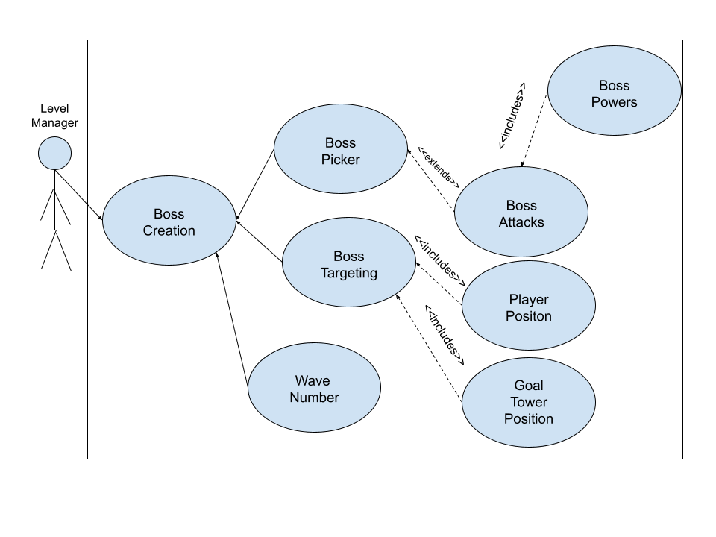

### Scenarios

**[You will need a scenario for each use case]**

**Name:** Boss Creation

**Summary:** Creates the boss and goes through the processes to do so

**Actors:** Level Manager

**Preconditions:** Boss need has been initialized.

**Basic sequence:**

**Step 1:** Figure out wave number

**Step 2:** Pick boss based on wave number

**Step 3:** Find boss targeting whether it be the player or man tower

**Step 4:** Initialize bosses attacks

**Step 5:** Initialize bosses powers

**Exceptions:**

**Step 1:** If not the correct wave number, the boss will not spawn

**Step 2:** If not the proper wave for a certain boss, the boss won’t spawn

**Post conditions:** Boss is created and displayed to the player on screen

**Priority:** 2-3

*The priorities are 1 = must have, 2 = essential, 3 = nice to have.

## Data Flow diagram(s) from Level 0 to process description for your feature _______14

### Data Flow Diagrams:

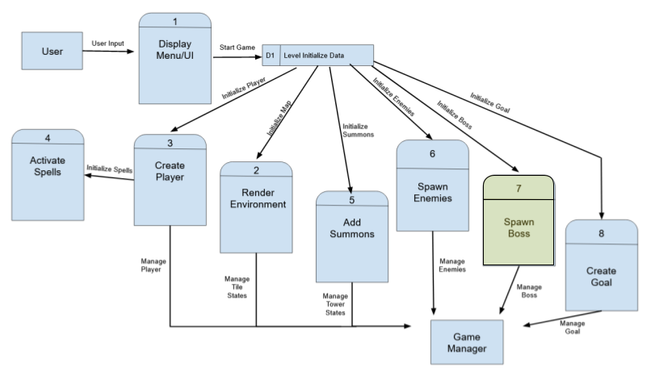

### Process Descriptions

Create Boss*

WHILE Wave Number is proper number

StartBossCreation

END WHILE

If NOT Proper Wave Number do not spawn Boss

If Proper wave Number Create Boss Based on Proper Wave Number

Boss Will Be created and assigned special abilities based on Wave Number

While Boss has been created target either player or goal tower.

## Acceptance Tests ________9

For my feature of creating bosses, over spawning of bosses should not be an issue do to the fact only one boss will spawn on its specified wave, To make sure of this we will make it so the boss has to be killed before a wave can end. Once a wave ends the BossCreation shall check the current wave number and spawn its specified boss with its certain sprite, to make sure this happens we will run the game sequence 1000 times in order to make sure the boss spawning is full proof with no errors. We will also have to make sure that the boss abilities are turned to null and reset after every boss is defeated so the next boss can respawn with a different sprite, ability, etc.

## Timeline _________/10

### Work items

|  |  |  |
| --- | --- | --- |
| Task | Duration (hrs) | Predecessor Task(s) |
| 1. Sprite Aspects | 6 | - |
| 2. Tower Design | 8 | 1 |
| 3. Enemy Design | 8 | 2 |
| 4. Player Design | 10 | 3 |
| 5. Obstacle Design | 5 | 4 |
| 6. Animation Design | 9 | 5 |
| 7. Spell Design | 6 | 6 |
| 8. Boss Creation and Design | 6 | 7 |

### Pert diagram

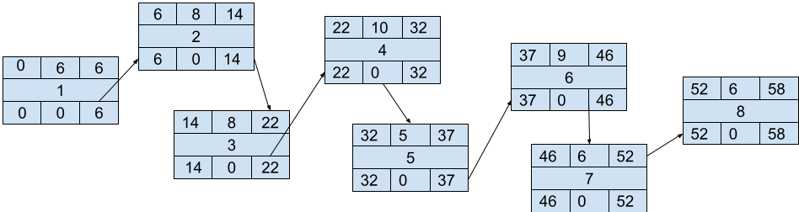

### Gantt timeline

